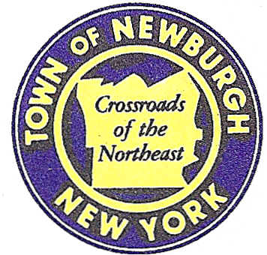

TOWN OF NEWBURGH
_______Crossroads of the Northeast __________________________
OLD TOWN HALL
308 GARDNERTOWN ROAD NEWBURGH, NEW YORK 12550

PLANNING BOARD
JOHN P. EWASUTYN, CHAIRMAN
TELEPHONE 845-564-7804
FAX 845-564-7802
E-MAIL: planningboard@townofnewburgh.org

PLANNING BOARD AGENDA

November 17th, 2016

*PLEASE NOTE: The Planning Board Meeting will start at 7:00 P.M. and all Applicants/Representatives
are to be present at that time. The Meeting will be held in the Meeting Room of Town Hall,
located at 1496 Route 300, Newburgh NY.*

1. Peak Summit Subdivision (16-13) PUBLIC HEARING
Fostertown Road
Section 17, Block1, Lot 40.2
Zone: R2
Rep: Zen Design
6 Old North Plank Road
Newburgh, NY 12550

2. Rivera Lot Line Change (16-20) INITIAL APPEARNACE
Countryman Lane LOT LINE CHANGE
Section 16, Block1, Lot 1.21, 2.14 & 96
Zone: AR
Rep: Mecurio-Norton-Tarolli-Marshall, Engineering & Land Surveying
45 Main Street- PO Box 166
Pine Bush, NY 12566

*WORK SESSION*
Project Readiness Discussion scheduled for 5:30 p.m. in the Meeting Room of
Town Hall on Thursday, November 17th, 2016.*

PLANNING BOARD BUSINESS
WORK SESSION

1. Trinity Square (08-07) 6 month extension November 17, 2016 to May 17, 2017.

*WORK SESSION*
Project Readiness Discussion scheduled for 5:30 p.m. in the Meeting Room of
Town Hall on Thursday, November 17th, 2016.*

